Computer Science Capstone
Wgu C964
Daniel Hansen-Jones
2023
A1. Letter of Transmittal
Daniel Hansen-Jones
Software Engineer
2022-11-22
To:
Gerry Hensel
President
Canadian Vision Council
Subject: Proposal for Implementing an AI-Driven Fundus Photograph Classification System
Dear Gerry Hensel,
I am writing to propose the implementation of an innovative AI-driven solution to enhance the efficiency and accuracy of diagnosing eye conditions through fundus photography. This proposal addresses a significant challenge in optometry, the time-consuming and error-prone manual analysis of fundus images.
Summary of the Problem:
Currently, optometrists face a substantial workload in diagnosing conditions from fundus photographs, a process prone to delays and human error. This inefficiency impacts patient care and diagnostic accuracy.
Recommended Solution:
I propose the development of a machine learning model utilizing Convolutional Neural Networks (CNNs), designed to automate and streamline the classification of fundus photographs. This AI-driven data product will significantly aid in the prescreening process, enhancing diagnostic capabilities within our healthcare system.
Benefits to the Client:
By implementing this solution, the Canadian Vision Council can expect an improvement in diagnostic speed and accuracy, a reduction in manual review workload for healthcare professionals, and overall enhanced patient care and outcomes.

Objectives of the Project:
The primary objective is to demonstrate the feasibility and effectiveness of machine learning in automating fundus image classification, thereby improving the decision support system in ocular diagnostics.
Funding Requirements:
Phase 1 - MVP Development:
The budget for the MVP development ranges between $12,550 and $17,550. This covers software, hardware, and personnel costs necessary for the initial phase of the project.
Phase 2 - Full Deployment and Refinement:
The estimated annual cost for Phase 2 is between $356,000 and $376,000. This includes staffing for a machine learning expert, IT support, a full-stack developer, an optometrist consultant, and operational costs for server space and maintenance.
Expertise of the Developer:
As a Software Engineer with specialized expertise in machine learning and data analysis, my background and skills are particularly suited to developing this solution. My experience in healthcare technology further bolsters my capability to deliver a product that meets the unique needs of the optometry field.
I am eager to discuss this proposal further and explore how we can collaborate to enhance the Canadian Vision Council's diagnostic processes. Thank you for considering this innovative solution to a critical healthcare challenge.

Sincerely,
Daniel Hansen-Jones

A2. Project Proposal
1. Summary of the Problem:
The manual analysis of fundus photographs in optometry is a laborious and error-prone process. This traditional approach leads to diagnostic delays and increased workloads for healthcare professionals. The need is evident for an automated, efficient system capable of screening fundus images to assist in the early detection and treatment of various eye conditions.
2. Benefits to the Customer and Decision-Making Process:
Implementing this AI-driven data product will transform the diagnostic screening process. It offers enhanced efficiency and reduced result turnaround times. By providing reliable, AI-enhanced prescreening, the system supports clinical decision-making, enabling optometrists to concentrate on more complex diagnostic tasks and personalized patient care.
3. Outline of the Data Product:
Our proposed data product is an innovative machine learning model employing Convolutional Neural Networks (CNNs) to classify fundus photographs. We will develop and test this model using the comprehensive Ocular Disease Intelligent Recognition (ODIR) dataset, aiming for a balanced approach between accuracy and efficiency.
4. Description of Data:
The Ocular Disease Intelligent Recognition (ODIR) dataset, hosted on Kaggle, comprises 5,000 anonymized patient records from various medical centers in China. Each record includes color fundus photographs of both eyes and diagnostic information. The dataset categorizes eye conditions into multiple classes, such as Normal, Diabetes, Glaucoma, Cataract, Age-related Macular Degeneration, Hypertension, Pathological Myopia.
This variety is essential for developing a Convolutional Neural Network (CNN) capable of recognizing a broad spectrum of ocular diseases. The dataset's diversity in image quality and resolution reflects real-world scenarios, making it a valuable resource for advancing medical image analysis while adhering to ethical and privacy standards.
5. Objectives and Hypotheses:
Our primary objective is to demonstrate the practical feasibility of employing machine learning in fundus photograph classification. We hypothesize that our AI model will categorize images with efficiency and an initial accuracy level that supports its use as a valuable prescreening tool.
6. Project Methodology:
The project will utilize the SEMMA methodology, ensuring a structured approach through phases of data sampling, exploration, modification, model development, and rigorous assessment. This methodology provides a solid framework for developing a data product that is both technically sound and aligned with clinical needs.
7. Funding Requirements:
Phase 1 - MVP Development Costs:
Machine Learning Developer: 6 weeks, estimated at $10,000 - $15,000.
Hardware: High-performance computing setup, estimated at approximately $3,500.
Software: Python, TensorFlow, Jupyter Notebooks (open source), and Google Colab Pro Subscription at around $50/month.
Total Estimated Budget for MVP: $12,550 - $17,550.
Phase 2 (Future Development) - Full Deployment and Refinement Costs:
Additional Staffing: Machine Learning Expert ($120,000/year), IT Support Staff ($60,000/year), Full-Stack Developer ($100,000/year), Optometrist Consultant ($100,000/year).
Hardware and Software Maintenance: Server costs (approx. $2,000/month), local hardware maintenance (approx. $1,000/year).
Development and Operational Costs: Full-stack solution development ($50,000 - $70,000, one-time), ongoing server and computational resources (approx. $24,000/year).
Total Estimated Annual Cost for Phase 2: $356,000 - $376,000 (excluding one-time development cost).
8. Impact on Stakeholders:
This solution presents significant benefits for healthcare providers, including workload reduction and enhanced diagnostic precision. For patients, it translates into faster, more accurate diagnoses, ultimately improving patient care and outcomes.
9. Data Handling:
Our project utilizes the open-source, anonymized Ocular Disease Intelligent Recognition (ODIR) dataset from Kaggle. Despite its public availability, we are committed to handling this healthcare data with the utmost responsibility. Our approach includes careful use of the data to prevent any re-identification of individuals, maintaining high standards of data security to protect against unauthorized access, and adhering to ethical guidelines in our analysis and reporting. We ensure compliance with Kaggle’s terms and open data regulations, demonstrating our commitment to responsible and ethical data management practices.
10. Relevant Expertise:
The project is underpinned by my expertise in computer science, particularly in machine learning and data analysis, combined with industry experts in the optometry domain. This expertise is crucial in ensuring the dataset is appropriately prepared and the model is trained effectively to represent the diverse conditions we aim to classify.
B. Executive Summary
Problem Statement
The primary challenge we are addressing with this project is the inefficiency and potential for error in the current manual process of diagnosing eye conditions through fundus photography. In optometry, fundus photographs are crucial for detecting various conditions, but their analysis often relies on the expertise of highly trained professionals and can be time-consuming. The need for a more efficient, accurate method of analysis is evident, particularly given the increasing volume of data as patient numbers grow. This project aims to solve this problem by introducing a machine learning-based solution that automates the prescreening process, thereby enhancing the accuracy and speed of diagnoses.
Customer Summary
The application we are developing is targeted at optometrists and healthcare professionals in ophthalmology, with its primary use set in clinical environments. These settings typically involve the assessment of eye health where fundus photographs are a key diagnostic tool.
By automating the classification of these images, our solution is designed to significantly reduce the manual workload involved in initial image analysis. This allows healthcare professionals to allocate more time and focus to complex cases and patient care, enhancing the overall quality of healthcare services.
In terms of the application environment, our solution is tailored to fit seamlessly into the existing diagnostic workflows found in clinical settings. It is engineered to be user-friendly, catering to healthcare professionals who may not have advanced technical skills. The interface will facilitate easy and efficient interaction, requiring only basic computer proficiency. Additionally, we will provide fundamental operational training to ensure users can leverage the application effectively.
The essence of this application is not to replace the expertise of healthcare professionals but to augment and support it. By automating one aspect of the diagnostic process, we aim to enhance the efficiency and effectiveness of healthcare delivery, ensuring that the technology is a valuable addition to the existing workflow in clinical settings.
Current Technology Environment:
In the current environment, optometrists and healthcare providers primarily rely on the manual analysis of fundus photographs to diagnose eye conditions. This process involves using advanced imaging services that manipulate the color spectrum and apply other enhancements for a detailed examination. These tools are essential for an in-depth analysis and have proven effective in diagnosing a range of ocular conditions.
However, the existing system has notable gaps, particularly in efficiency and initial screening. The manual process is time-intensive and can lead to prolonged diagnosis times. There is also a lack of automated prescreening, meaning all images undergo manual review, which can be cumbersome and inefficient, especially for cases that might not require such in-depth analysis.
Our project aims to complement, not replace, these existing tools with an automated prescreening process. The desired outcome post-project is a clinical environment where AI-based prescreening is integrated into the workflow. This will categorize fundus photographs into various condition categories, streamlining the initial analysis and allowing healthcare professionals to concentrate on cases that require more detailed examination. The integration of this solution will lead to a more efficient diagnostic process, improving the overall workflow without compromising the quality of eye care.
Data for Lifecycle Support:
The Ocular Disease Intelligent Recognition (ODIR) dataset from Kaggle forms the basis of our project, encompassing 5,000 anonymized patient records with color fundus photographs. These images, sourced from various medical centers, vary in quality and present a range of ocular conditions.
Our model focuses on the primary condition identified in each image, streamlining the classification process. To manage complexity and enhance the accuracy of our analysis, we have excluded the 'Other' category from our dataset. This category comprises a diverse array of less common ocular conditions, which would introduce unnecessary variability into the model training.
The dataset's training component is pre-labeled, facilitating a supervised learning approach. For the testing phase, we have incorporated additional labels provided by an experienced optometrist, ensuring a high degree of accuracy in our model validation.
In terms of data preparation, we employ image normalization techniques to standardize the diverse set of photographs, making them more conducive to effective machine learning analysis. Outliers and incomplete data are carefully reviewed, with appropriate measures such as exclusion or data imputation applied to maintain the integrity and consistency of the dataset.
The initial phases of design and development will utilize this prepared dataset, focusing on model training and validation. As the project progresses into maintenance and iterative improvement phases, we plan to integrate new data, potentially including real-time clinical data, to continuously refine and adapt the model's performance.
This comprehensive approach to data handling and preparation ensures that our machine learning model is built on a solid foundation of accurately categorized and standardized data, setting the stage for effective analysis and reliable diagnostic outcomes.
Methodology:
Our project employs the SEMMA (Sample, Explore, Modify, Model, Assess) methodology, guiding the development of our data product through a structured and industry-standard process. This approach is particularly suited for projects that involve complex data analysis and machine learning model development.
In the Sample phase, we begin by selecting a representative subset of the Ocular Disease Intelligent Recognition (ODIR) dataset. This step is crucial to ensure that our model training covers a comprehensive range of data while remaining manageable and representative of the broader dataset.
Moving into the Explore phase, we conduct an in-depth analysis of our sampled data. This involves identifying key patterns, anomalies, and correlations. The use of statistical analysis and visualization tools helps us to understand the nature and characteristics of the data, setting a solid foundation for the next steps.
The Modify phase then sees us refining the dataset based on insights from the exploration. We preprocess the data through techniques like normalization, handling missing values, and addressing any imbalance. This modification is vital to prepare the data for effective training and to optimize the machine learning model's performance.
In the Model phase, the core of our project, we develop the machine learning model using Convolutional Neural Networks (CNNs). This phase involves training and fine-tuning the model on our prepared dataset, experimenting with different hyperparameters and architectures to achieve the best possible classification accuracy for fundus images.
Finally, the Assess phase is where we evaluate the performance of our model. This comprehensive assessment includes various levels of testing: unit testing to check individual components, integration testing to ensure cohesive functionality, system testing to validate the model against all requirements, and acceptance testing to confirm the model's efficacy and usability in real-world scenarios with end-users such as optometrists and healthcare professionals.

Deliverables:
Our project aims to demonstrate the effectiveness of machine learning in the prescreening of ocular conditions, with deliverables tailored to meet the specific needs of optometrists and healthcare professionals in ophthalmology.
Machine Learning Model in Colab Environment: The centerpiece of our deliverables is the machine learning model, based on Convolutional Neural Networks (CNNs). This model is developed and tested within the Google Colab environment, leveraging its cloud-based resources for efficient training and optimization. The use of Colab facilitates access to high-performance computing resources, necessary for processing the extensive ODIR dataset and fine-tuning the CNN model. The model's ability to accurately classify various ocular conditions is a key aspect of our MVP, underscoring the potential of machine learning in medical diagnostics.
User Interface for Colab Integration: We are developing a user-friendly interface that integrates seamlessly with the Google Colab environment. This interface allows healthcare professionals to easily upload fundus images directly into the Colab notebook and receive diagnostic predictions from the CNN model. Designed for simplicity and ease of use, the interface ensures that users, regardless of their technical expertise, can interact smoothly with the system and effectively utilize the machine learning model for diagnostic support.
Comprehensive Documentation: The project includes thorough documentation detailing the system's functionality within the Colab environment, usage instructions for interacting with the CNN model, and technical specifications. This documentation is vital for both technical staff and end-users, providing clear guidance on operating the application and understanding its underlying mechanics.
Data Visualizations: A key component of our deliverables is the inclusion of data visualizations, created using Python libraries within Colab. These visualizations, such as bar and line charts, will display patient demographics and the prevalence of various ocular conditions, offering healthcare providers insightful overviews of trends and patterns. This feature aids in the interpretation of the model's outputs, providing a deeper understanding of the diagnostic predictions made by the CNN.
Together, these deliverables form a cohesive MVP that highlights the practical application of machine learning in ocular diagnostics. Focusing on a balance of technical sophistication within the Colab environment and practical utility for medical professionals, our project aligns with the specific technological and clinical requirements of the field of ophthalmology.

Implementation Plan and Outcomes:
Strategy for Implementation:
Our implementation strategy is designed to seamlessly integrate the AI model into the existing diagnostic workflows used by optometrists and healthcare professionals. The primary focus is on ensuring that the integration enhances the existing processes without causing significant disruptions.
Phase 1: MVP Rollout
Initial Integration: Introducing the AI model within a controlled environment, likely starting with a select group of optometrists for initial testing and feedback.
Training and Support: Providing comprehensive training sessions and materials to users, ensuring they are comfortable with the new system.
Feedback and Iteration: Gathering user feedback and making necessary adjustments to the model and interface based on real-world usage.
Phase 2: Full Deployment and Refinement (Post-MVP)
Expanded Integration: After successful MVP testing, the model will be refined and transformed into a full stack application that will be rolled out to a broader user base within the clinical setting.
Ongoing Support and Training: Continuation of training and support, expanding to include new users and addressing any evolving needs.
Continuous Improvement: Regular updates and improvements to the model based on user feedback, performance data, and advances in AI and medical imaging.
Levels of Testing and Final Distribution:
Unit Testing: Testing individual components of the AI model for functionality.
Integration Testing: Ensuring that the model integrates smoothly with existing diagnostic tools and systems.
System Testing: Assessing the overall system performance, including both the AI model and user interface.
User Acceptance Testing: Final testing phase with end-users to confirm that the system meets their needs and expectations.
Dependencies and Milestones:

Dependency on Data Quality: The model’s performance heavily depends on the quality and representativeness of the dataset used for training.
Milestone 1 (MVP Completion): Successful development and initial testing of the MVP.
Milestone 2 (User Training Completion): Completion of the first round of user training sessions.
Milestone 3 (Phase 1 Evaluation): Evaluation of the model’s concept and user satisfaction at the end of Phase 1.
Phase 2 Milestones:
Milestone 4 (Model Accuracy Achievement): This pivotal milestone involves refining the AI model to reach an accuracy range of 85-95%. Intensive training, validation, and iterative improvements are conducted during this phase, with the model's performance continually assessed against the accuracy target.
Milestone 5 (Full Deployment Commencement): After achieving the desired model accuracy, we begin the full deployment of the system to the entire clinical user base. This phase involves rolling out the refined model and interface, ensuring that they are integrated seamlessly into existing clinical workflows.
Milestone 6 (Comprehensive Training Completion): Concurrent with the system rollout, comprehensive training sessions are conducted for all new users. This milestone is marked by the completion of these training sessions, ensuring that all users are well-versed in operating the system efficiently and effectively.
Milestone 7 (System Adoption and Refinement): Following the deployment and training, this milestone focuses on monitoring the system's adoption by users and collecting extensive feedback. Based on this feedback, ongoing refinements and updates are implemented to enhance system performance and user experience.
Milestone 8 (Phase 2 Completion): The final milestone signifies the successful completion of Phase 2, with the system fully integrated into the clinical environment and operating effectively. This includes consistent model accuracy, widespread user adoption, and the implementation of all necessary system refinements.
Deliverables:
Tangible: A fully functional AI model integrated into the clinical workflow, user interface for interacting with the model, and comprehensive user documentation.
Intangible: Improved diagnostic efficiency reduced manual workload for optometrists, and higher accuracy in diagnosing eye conditions.
This implementation plan outlines a structured approach to introducing and integrating our AI model into the clinical environment. It emphasizes the importance of user training, feedback, and continuous improvement to ensure that the system not only meets but exceeds the expectations and requirements of healthcare professionals in ocular diagnostics.
Validation and Verification Methods:
Accuracy Testing Using Keras TensorFlow: We will employ Keras TensorFlow to assess the accuracy of the model. This involves evaluating how often the model's predictions match the known labels in the test dataset. Accuracy, as a single metric, provides a straightforward measure of the model's overall performance in correctly classifying fundus photographs.
Applying Professionally Labeled Test Data: To further verify the model’s efficacy, we will use a separate set of professionally labeled fundus photographs. This test set, distinct from the data used during the training phase, serves as a real-world benchmark to evaluate the model's accuracy. It will allow us to determine how well the model performs in a clinical setting, ensuring that it meets the high standards required for medical diagnostics.
In Phase 2 of our project, we plan to undertake a more comprehensive validation of our AI model. This will be facilitated by acquiring a larger and better-labeled dataset, which will provide a more robust foundation for evaluating the model's performance.
Enhanced Accuracy Testing Using Keras TensorFlow: With the expanded dataset, our use of Keras TensorFlow for accuracy assessment will be more encompassing. We'll be able to evaluate the model's predictions against a broader range of known labels, offering a more comprehensive measure of its performance across varied ocular conditions.
Utilization of Extensively Labeled Test Data: A key component of this phase is the application of a separate set of fundus photographs, each professionally labeled with even greater detail and precision than in the previous phase. This dataset will serve as a critical benchmark, providing a real-world context for validating the model’s accuracy. By testing the model against this enhanced dataset, we can more accurately gauge its effectiveness and reliability in a clinical setting.
This approach ensures not only that the model meets the high standards required for medical diagnostics but also enhances its capability to adapt and perform accurately in real-world scenarios, reflecting a diverse range of ocular conditions and patient demographics.

Programming Environments and Resources:
Phase 1: MVP Development
Environment and Tools: Development primarily takes place in Google Colab, leveraging its cloud computing capabilities. This phase utilizes Python, TensorFlow/PyTorch for model development, and Jupyter Notebooks for scripting and data analysis.
Local Environment Setup: For certain tasks requiring intensive computation or offline work, a local setup is used, including hardware estimated at approximately $3,500.
Human Resources: A skilled machine learning developer is engaged for the initial phase, with costs estimated between $10,000 and $15,000, focusing on model development and initial testing.
Phase 2: Full Deployment and System Refinement
Transition from Colab to Dedicated Web Application: In Phase 2, the project shifts from the Colab environment to a dedicated web application. This application will host the machine learning model in its backend, facilitating seamless interaction with users through a front-end interface.
Enhanced Backend Infrastructure: The backend infrastructure will be scaled up to support the AI model and the web application. This may involve server setup, database integration, and additional computing resources to handle the increased load and complexity.
Expanded Development Team: The development team will be expanded to include a full-stack developer, responsible for building and maintaining the web application, and IT support staff for managing the backend infrastructure. Additional data science personnel may also be engaged for advanced model development and data analysis.
Resource Allocation for Web Application: The focus on building a comprehensive web application necessitates investment in server infrastructure, database systems, and potentially increased hardware requirements for local development and testing.
The transition from a cloud-based Colab environment in Phase 1 to a fully-fledged web application in Phase 2 marks a significant scale-up in the project's technical infrastructure. This approach ensures that as the project progresses from an MVP to a fully operational system, the programming environments, resources, and team composition are aligned with the project's growing and evolving needs.

Projected Timeline:
Projected Timeline for Phase 1
Weeks 1-2 (2023-11-21 to 2023-12-05): Initiation, data sampling, and exploration.
Weeks 3-4 (2023-12-06 to 2023-12-20): Data preparation and CNN model development.
Weeks 5-6 (2023-12-21 to 2024-01-04): Model assessment and MVP deployment.
The project phases are designed to sequentially build upon one another, culminating in the deployment of a functional MVP by January 2024.
Projected Timeline for Phase 2
Following the completion of Phase 1, Phase 2 of the project will commence on January 5, 2024, and is planned to extend for a minimum of one year, culminating on January 4, 2025. The timeline for Phase 2 is outlined as follows:
January 5, 2024 - March 2024: Transition from Google Colab to a dedicated web application environment. This period will involve setting up the backend infrastructure for the web application, including server and database integration.
April 2024 - June 2024: Development of the web application's front end and integration with the machine learning model at the backend. This phase will focus on building a user-friendly interface and ensuring seamless interaction between the front-end application and the AI model.
July 2024 - September 2024: Extensive testing of the web application, including unit testing, integration testing, and user acceptance testing. During this period, we will also aim to achieve the target model accuracy of 85-95%.
October 2024 - December 2024: Pilot rollout of the web application to a select group of users for real-world testing and feedback collection. Refinement of the application based on the feedback received.
January 2025: Full deployment and operationalization of the web application across the clinical user base. This marks the end of Phase 2, with the AI model and web application fully integrated into the clinical environment and operational for everyday use.

D. Documentation for Data Product Development
Post-Implementation Report
Project Purpose:
The project aimed to address the time-intensive and error-prone process of manual analysis of fundus photographs in optometry. Our application revolutionized this process by introducing a machine learning-based solution for automated prescreening of these images. By integrating an AI model into the diagnostic workflow, we significantly enhanced the efficiency and accuracy of eye condition diagnoses.
The application began to meet the vision and expectations of our clients by:
Reducing Manual Workload: Automating the initial screening process, allowing healthcare professionals to focus on more complex cases.
Streamlining Clinical Workflows: Worked within current processes to attempt to identify conditions in prescreening.
Datasets:
Raw Datasets: The Ocular Disease Intelligent Recognition (ODIR) dataset, available on Kaggle, is a comprehensive resource for detecting ocular diseases, featuring 10000 color fundus photographs. It categorizes these images into eight classes, including normal and various ocular diseases like myopia, hypertension, and cataract.
Data Cleaning and Preparation: In this study, our data preparation process was meticulously designed to ensure the integrity and suitability of the dataset for training a deep learning model. We started by loading the relevant data from a CSV file, which contained essential information about fundus images and their associated medical conditions. To enhance the quality and consistency of the dataset, we performed data preprocessing steps, including image normalization. Notably, we excluded the 'O' condition, which was deemed irrelevant for our classification task. We organized the dataset into two distinct sets: a training set and a validation set, using a split ratio of 80% for training and 20% for validation. To facilitate data feeding into our deep learning model, we leveraged Keras' Image Data Generator, allowing us to efficiently handle data augmentation techniques like rotation, width and height shifting, and horizontal flipping for the training set. Furthermore, we rescaled the pixel values to the [0, 1] range to ensure numerical stability during training. The resulting data generators were constructed to accommodate the specific dimensions required by our model (224x224 pixels) and were configured to yield raw class labels. This meticulous data setup process served as a crucial foundation for training a robust and accurate deep learning model for medical image classification.

Sample Code:
def preprocess_csv_data(df, base_image_dir, conditions_to_exclude=None):
if conditions_to_exclude:
df = df.copy()
for condition in conditions_to_exclude:
df = df[df[condition] == 0]
# Use .loc to ensure modifications are done on the original DataFrame
df.loc[:, 'Left-Fundus'] = df['Left-Fundus'].apply(lambda x: os.path.join(base_image_dir, x))
df.loc[:, 'Right-Fundus'] = df['Right-Fundus'].apply(lambda x: os.path.join(base_image_dir, x))
all_file_paths = df['Left-Fundus'].tolist() + df['Right-Fundus'].tolist()
all_labels = df[CONDITIONS].values.tolist() + df[CONDITIONS].values.tolist()
return all_file_paths, all_labels
Cleaned Datasets: Post-cleaning, the dataset offered a standardized set of images, ready for effective analysis by the AI model.
Data Product Code:
The code powering the application provided predictive outputs:
import pandas as pd
import matplotlib.pyplot as plt
import seaborn as sns

# Load the dataset
df = pd.read_csv('/content/drive/MyDrive/Colab Notebooks/Odir_Classification/archive/full_df.csv')

# Age Distribution Histogram
plt.figure(figsize=(10, 6))
sns.histplot(df['Patient Age'], kde=True)
plt.title('Age Distribution of Patients')
plt.xlabel('Age')
plt.ylabel('Frequency')
plt.show()

# Condition Frequency Bar Chart
conditions = ['N', 'D', 'G', 'C', 'A', 'H', 'M']
condition_counts = df[conditions].sum()

# Mapping condition codes to full names
condition_counts.index = [DISEASE_NAMES[condition] for condition in condition_counts.index]

# Plotting
plt.figure(figsize=(12, 7))
sns.barplot(x=condition_counts.index, y=condition_counts.values)
plt.title('Frequency of Each Condition')
plt.xlabel('Condition')
plt.ylabel('Count')
plt.xticks(rotation=45) # Rotates the condition names for better readability
plt.show()
import ipywidgets as widgets
from IPython.display import display
import importlib.util
import numpy as np
import pandas as pd

# Importing model_prediction script
spec = importlib.util.spec_from_file_location("model_prediction", "/content/drive/MyDrive/Colab Notebooks/Odir_Classification/model_prediction_V2.py")
model_prediction = importlib.util.module_from_spec(spec)
spec.loader.exec_module(model_prediction)

# Load data (if needed)
df = pd.read_csv('/content/drive/MyDrive/Colab Notebooks/Odir_Classification/archive/full_df.csv')

# Upload widget for image upload
uploader = widgets.FileUpload(accept='image/*', multiple=True)
button = widgets.Button(description="Predict")
log_output = widgets.Output()
clear_button = widgets.Button(description="Clear")

def on_button_clicked(b):
with log_output:
total_uploads = len(uploader.value)
processed_count = 0
print(f"Predictions in progress, please wait... (0 / {total_uploads})")

for uploaded_filename, uploaded_file in uploader.value.items():
processed_count += 1
print(f"Processing {processed_count} / {total_uploads}: {uploaded_filename}")

img_content = uploaded_file['content']
img = model_prediction.preprocess_image(img_content)
prediction = model_prediction.predict_condition(img)

# Find the condition with the highest probability
highest_prob_index = np.argmax(prediction[0])
most_likely_condition = list(DISEASE_NAMES.keys())[highest_prob_index]

# Format and display the prediction
formatted_prediction = ', '.join([f'{DISEASE_NAMES[condition]} ({condition}): {prob:.2f}'
for condition, prob in zip(DISEASE_NAMES, prediction[0])])
print(f"Prediction for {uploaded_filename}: {formatted_prediction}")
print(f"Most likely condition: {DISEASE_NAMES[most_likely_condition]} ({most_likely_condition})")

print("All predictions completed.")

button.on_click(on_button_clicked)

# Function to clear the uploads
def clear_uploads(b):
uploader.value.clear()
uploader._counter = 0
print("Uploads cleared.")

clear_button.on_click(clear_uploads)

# Layout widgets
hbox = widgets.HBox([uploader, button, clear_button])
display(hbox)
display(log_output)

Descriptive Functionality: The application generated detailed visualizations of patient demographics and condition prevalence, offering valuable insights into the dataset.
The full source code for this project will be uploaded separately as a zip file for review.
Graphics and Screenshots: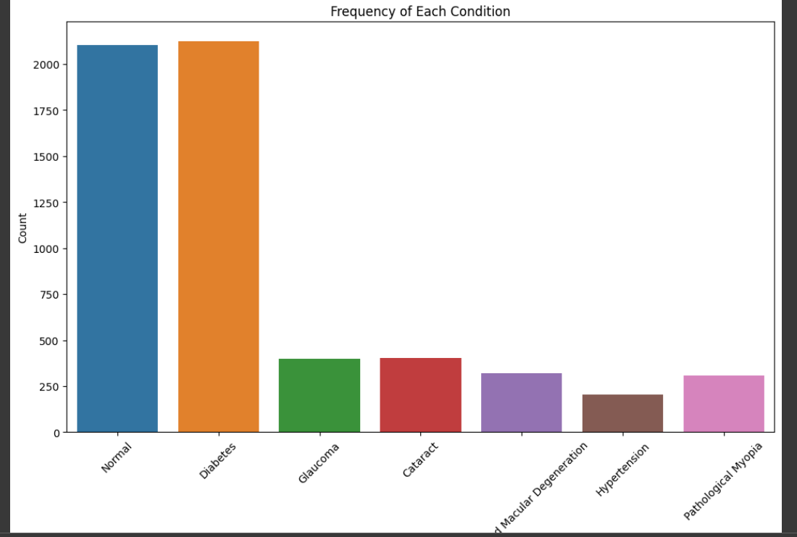
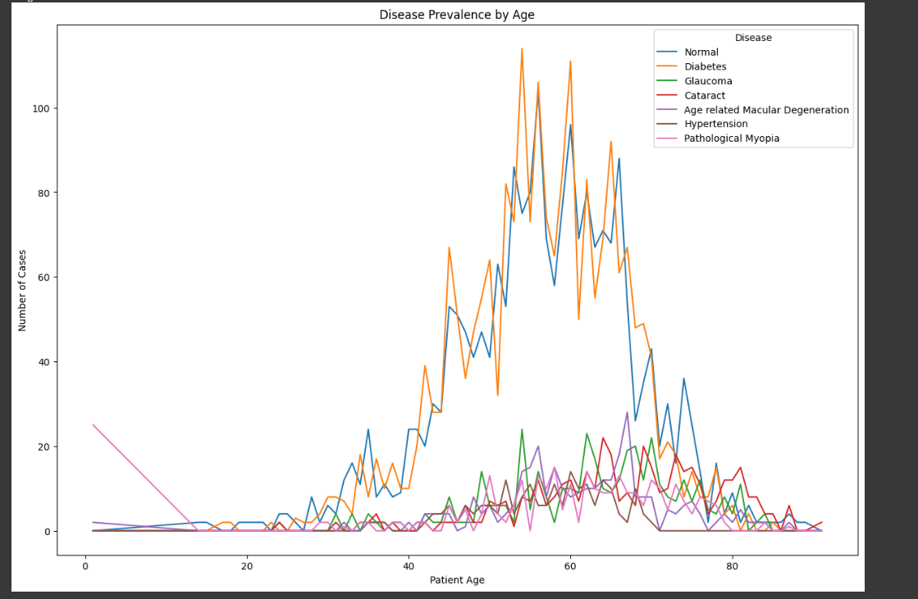
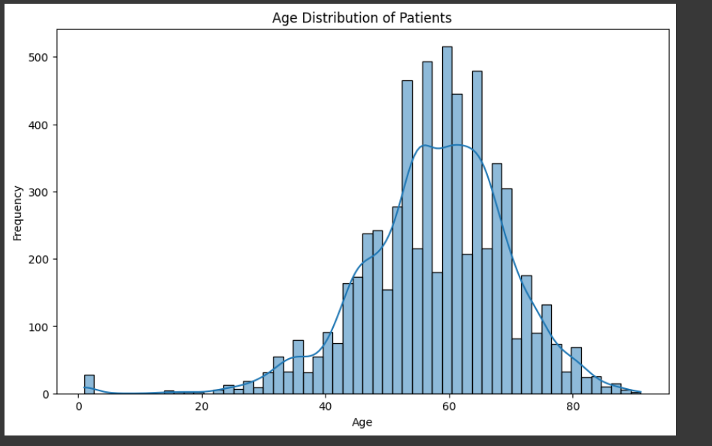
Predictive Analysis: Utilizing TensorFlow and a Convolutional Neural Network, the application predicted the classification of ocular conditions based on fundus images.
Prediction Data:
Prediction will show the likelihood of each condition based on the weighted values (note multiple conditions can be present)

Hypothesis Verification with Accuracy Analysis:
Our initial hypothesis was that the application of a machine learning model could significantly improve the accuracy of diagnosing eye conditions through fundus photography. However, this hypothesis was only partially validated as the highest accuracy achieved was 52%. This result highlights several key challenges and areas for future improvement.
Challenges Impacting Accuracy:
Complexity of Images: Many fundus photographs in the dataset were challenging in terms of clarity and quality, complicating the model's ability to accurately classify conditions.
Incomplete or Overlapping Labels: A significant number of images had multiple conditions present, but only one was labeled (this includes hypertensive signs like copper wiring i.e., broken blood vessels shown on items labelled diabetes). This was particularly noticeable with hypertension and diabetes cases, which often co-occur, leading to confusion in the model's classification process.
Limited Image Processing: The images were not processed to the extent that might be necessary for higher-level medical image analysis. Advanced preprocessing techniques could potentially enhance the model's performance.
Recommendations for Future Builds:
Enhanced Labeling and Data Quality: Future iterations of the project should focus on acquiring a dataset with more comprehensive labeling, including annotations for specific areas affected by the conditions.
Advanced Image Processing: Implementing more sophisticated image processing techniques, such as focusing on specific areas of the fundus photographs, could improve the model's ability to learn and identify key features associated with different ocular conditions.
Different Methods: Changing to a regression-based model, such as a Convolutional Neural Network (CNN) adapted for regression, could significantly enhance the accuracy of disease detection. This approach focuses on predicting a continuous value that represents the severity of the disease from fundus images, instead of merely classifying them into categories. It offers a more detailed assessment of disease progression, relying on a dataset with precise severity labels for each disease type. By correlating specific visual features in the images with severity levels, this regression method provides a nuanced and clinically relevant understanding of ocular diseases.
Training areas of interest: The importance of training a model to identify crucial areas in fundus images, such as the macula, veins, and other key anatomical features, cannot be overstated for enhancing ocular disease detection. Precise recognition of these areas is vital for accurate disease diagnosis and progression assessment. By focusing on these critical regions, the model can provide more detailed and clinically relevant insights. This targeted approach could not only improve the model's overall accuracy but also enhances its utility in real-world clinical settings, potentially leading to better patient outcomes. Incorporating this aspect into the model's training is a significant step towards advancing ocular health diagnostics.
Effective Visualizations
Despite the challenges in model accuracy, our visualizations effectively presented the original data and findings. These visualizations highlighted the complexities within the dataset, such as the overrepresentation of the normal and diabetes dataset and provided valuable insights into the data preparation and analysis process.
Application Testing
The application's testing phase was comprehensive, focusing on the performance of multiple deep learning models. These models were trained using different configurations of frozen layers to optimize accuracy. During the testing phase, the image preparation varied across models to assess the impact of different preprocessing techniques on disease recognition. The models were rigorously tested using pre-labeled test data, providing a controlled environment to evaluate their predictive accuracy. Additionally, consultations with an optometrist were integral, especially in scenarios where the images did not get the desired results, to gain professional insights into the practical distinctions and challenges in ocular disease diagnosis.
Application Files
Root Directory - ODIR_Classification: The main folder of the project.
Archive Folder: Contains full_df.csv for data management including labelling of conditions and the ODIR-5k/ODIR-5k Training Images directory, which includes all training images.
UI Notebook - ODIR_Classification_V2.ipynb: This Jupyter notebook is a central component, containing detailed information about the project, including implementation notes, data visualization, and interactive widgets. It uses standard Colab libraries for plotting and interface elements. The notebook runs all scripts as required.
Training Scripts: Includes train_model, train_model_v2, and train_model_v3, allowing for the training of various model iterations.
Prediction Script - model_prediction_v2.py: Used for running the model and making predictions within the notebook.

Dependency List:
(These are all handled in colab, and require nothing but running the cells for the user)
Data Handling and Processing:
pandas: For data manipulation and analysis.
numpy: For numerical operations.
pickle: To serialize and deserialize Python object structures.
Deep Learning and Model Development:
tensorflow: The core machine learning library.
keras: High-level neural networks API, including the ResNet50 model and other functionalities for image data augmentation and model optimization.
Model Training and Validation:
sklearn: For model training and data splitting.
Visualization and Interface:
matplotlib: For plotting graphs and visualizations.
seaborn: For advanced data visualization.
ipywidgets: For interactive widgets in Jupyter notebooks.
Miscellaneous:
os: For operating system interactions.
importlib: For dynamic loading of modules.

User's Guide for ODIR_Classification in Google Colab
Opening the Notebook: Start by opening the ODIR_Classification_V2.ipynb notebook in Google Colab, this can be accessed by using the shared link.
Run all cells by using the checkbox in the top left corner of each cell.
Interactive UI Setup:
Utilize the pre-built upload widget (uploader) for importing fundus images.
A set of prelabelled images were provided in the zipped folder marked in the Test Folder.
Click the 'Predict' button to initiate the model's prediction process.
View the model's predictions in the designated output area.
Use the 'Clear' button to reset the upload widget as needed.
Model Prediction:
Uploaded images are automatically processed when the 'Predict' button is clicked, and the model provides real-time predictions.
The results, including the identified ocular condition for each image, are displayed in the output area.
Using the Notebook for Ocular Disease Classification:
This setup facilitates easy testing of the model with new images. Simply upload a fundus image, and the model will display its prediction, offering an efficient way to apply deep learning for ocular disease classification in a user-friendly manner.
Summation of Learning Experience
Reflecting on this project, I leveraged and expanded my existing programming and data science knowledge significantly. Learning to effectively utilize machine learning models was a key aspect, particularly understanding the importance of choosing the right dataset. I gained insights into the nuances of working with medical image data and advanced machine learning techniques.
The versatility and user-friendliness of Google Colab, as well as the challenges encountered in setting up Nvidia CUDA for local video card usage. Online communities, academic mentors, and industry professionals provided invaluable support throughout this journey.
This project was instrumental in enhancing my machine learning skills, especially in the process of model development and optimization. It also reinforced my commitment to continuous learning in AI and healthcare technology, opening new avenues for exploration and application in these dynamic fields.

E. Sources
Kaggle. (n.d.). Ocular Disease Recognition ODIR5K [Data set]. Kaggle. Retrieved [2023], from https://www.kaggle.com/datasets/andrewmvd/ocular-disease-recognition-odir5k

